Fixed Income

Reading 50 FIXED-INCOME SECURITIES: DEFINING ELEMENTS

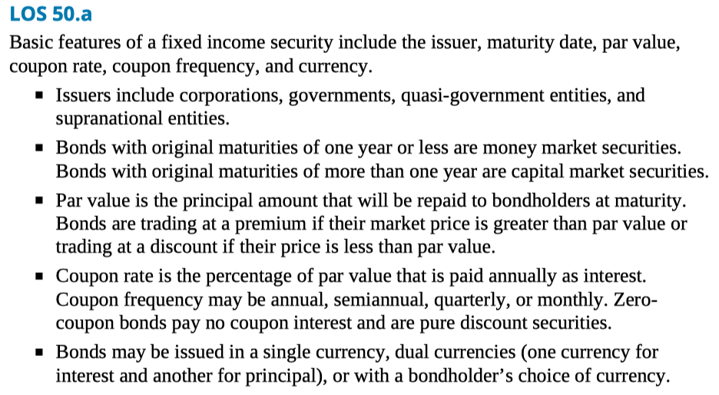

LOS 50.b A bond indenture or trust deed is a contract between a bond issuer and the bondholders, which defines the bond’s features and the issuer’s obligations. An indenture specifies the entity issuing the bond, the source of funds for repayment, assets pledged as collateral, credit enhancements, and any covenants with which the issuer must comply.

LOS 50.c Covenants are provisions of a bond indenture that protect the bondholders’ interests. Negative covenants are restrictions on a bond issuer’s operating decisions, such as prohibiting the issuer from issuing additional debt or selling the assets pledged as collateral. Affirmative covenants are administrative actions the issuer must perform, such as making the interest and principal payments on time.

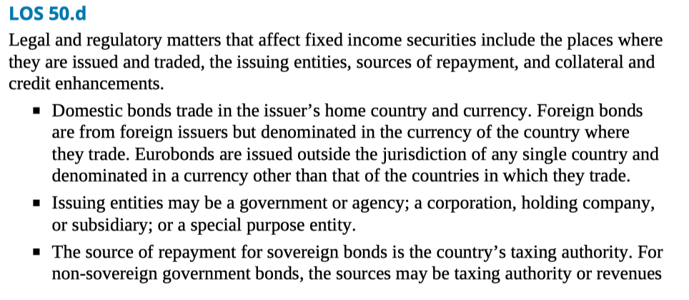

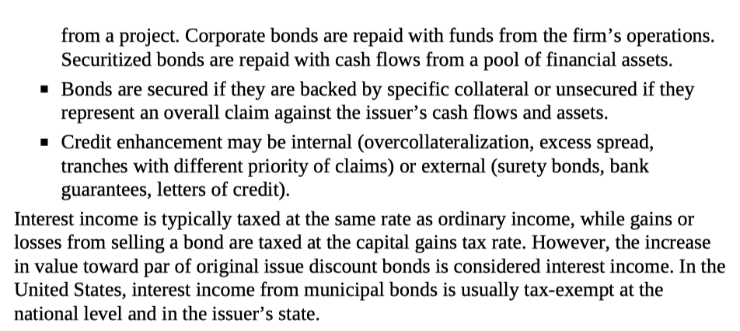

LOS 50.e A bond with a bullet structure pays coupon interest periodically and repays the entire principal value at maturity.

A bond with an amortizing structure repays part of its principal at each payment date. A fully amortizing structure makes equal payments throughout the bond’s life. A partially amortizing structure has a balloon payment at maturity, which repays the remaining principal as a lump sum.

A sinking fund provision requires the issuer to retire a portion of a bond issue at specified times during the bonds’ life.

Floating-rate notes have coupon rates that adjust based on a reference rate such as LIBOR.

Other coupon structures include step-up coupon notes, credit-linked coupon bonds, payment-in-kind bonds, deferred coupon bonds, and index-linked bonds.

LOS 50.f Embedded options benefit the party who has the right to exercise them. Call options benefit the issuer, while put options and conversion options benefit the bondholder.

Call options allow the issuer to redeem bonds at a specified call price.

Put options allow the bondholder to sell bonds back to the issuer at a specified put price.

Conversion options allow the bondholder to exchange bonds for a specified number of shares of the issuer’s common stock.

Reading 51 FIXED-INCOME MARKETS: ISSUANCE, TRADING, AND FUNDING

LOS 51.a Global bond markets can be classified by the following:

Type of issuer: Government (and government-related), corporate (financial and nonfinancial), securitized. Credit quality: Investment grade, noninvestment grade.

Original maturity: Money market (one year or less), capital market (more than one year). Coupon: Fixed rate, floating rate.

Currency and geography: Domestic, foreign, global, eurobond markets; developed, emerging markets. Other classifications: Indexing, taxable status.

LOS 51.b Interbank lending rates, such as London Interbank Offered Rate (LIBOR), are frequently used as reference rates for floating-rate debt. An appropriate reference rate is one that matches a floating-rate note’s currency and frequency of rate resets, such as 6- month U.S. dollar LIBOR for a semiannual floating-rate note issued in U.S. dollars.

LOS 51.c Bonds may be issued in the primary market through a public offering or a private placement.

A public offering using an investment bank may be underwritten, with the investment bank or syndicate purchasing the entire issue and selling the bonds to dealers; or on a best-efforts basis, in which the investment bank sells the bonds on commission. Public offerings may also take place through auctions, which is the method commonly used to issue government debt.

A private placement is the sale of an entire issue to a qualified investor or group of investors, which are typically large institutions.

LOS 51.d Bonds that have been issued previously trade in secondary markets. While some bonds trade on exchanges, most are traded in dealer markets. Spreads between bid and ask prices are narrower for liquid issues and wider for less liquid issues.

Trade settlement is typically T + 2 or T + 3 for corporate bonds and either cash settlement or T + 1 for government bonds.

LOS 51.e Sovereign bonds are issued by national governments and backed by their taxing power. Sovereign bonds may be denominated in the local currency or a foreign currency.

LOS 51.f

Non-sovereign government bonds are issued by governments below the national level, such as provinces or cities, and may be backed by taxing authority or revenues from a specific project.

Agency or quasi-government bonds are issued by government sponsored entities and may be explicitly or implicitly backed by the government.

Supranational bonds are issued by multilateral agencies that operate across national borders.

LOS 51.g Debt issued by corporations includes bank debt, commercial paper, corporate bonds, and medium-term notes.

Bank debt includes bilateral loans from a single bank and syndicated loans from multiple banks.

Commercial paper is a money market instrument issued by corporations of high credit quality.

Corporate bonds may have a term maturity structure (all bonds in an issue mature at the same time) or a serial maturity structure (bonds in an issue mature on a predetermined schedule) and may have a sinking fund provision.

Medium-term notes are corporate issues that can be structured to meet the requirements of investors.

LOS 51.h Structured financial instruments include asset-backed securities and collateralized debt securities as well as the following types:

Yield enhancement instruments include credit linked notes, which are redeemed at an amount less than par value if a specified credit event occurs on a reference asset, or at par if it does not occur. The buyer receives a higher yield for bearing the credit risk of the reference asset.

Capital protected instruments offer a guaranteed payment, which may be equal to the purchase price of the instrument, along with participation in any increase in the value of an equity, an index, or other asset.

Participation instruments are debt securities with payments that depend on the returns on an asset or index, or depend on a reference interest rate. One example is a floating rate bond, which makes coupon payments that change with a short-term reference rate, such as LIBOR. Other participation instruments make coupon payments based on the returns on an index of equity securities or on some other asset.

An inverse floater is a leveraged instrument that has a coupon rate that varies inversely with a specified reference interest rate, for example, 6% – (L × 180-day LIBOR). L is the leverage of the inverse floater. An inverse floater with L > 1, so that the coupon rate changes by more than the reference rate, is termed a leveraged inverse floater. An inverse floater with L < 1 is a deleveraged floater.

LOS 51.i

Short-term funding alternatives available to banks include:

Customer deposits, including checking accounts, savings accounts, and money market mutual funds. Negotiable CDs, which may be sold in the wholesale market.

Central bank funds market. Banks may buy or sell excess reserves deposited with their central bank. Interbank funds. Banks make unsecured loans to one another for periods up to a year.

LOS 51.j A repurchase agreement is a form of short-term collateralized borrowing in which one party sells a security to another party and agrees to buy it back at a predetermined future date and price. The repo rate is the implicit interest rate of a repurchase agreement. The repo margin, or haircut, is the difference between the amount borrowed and the value of the security.

Repurchase agreements are an important source of short-term financing for bond dealers. If a bond dealer is lending funds instead of borrowing, the agreement is known as a reverse repo.

Reading 52 Introduction to Fixed Income Valuation

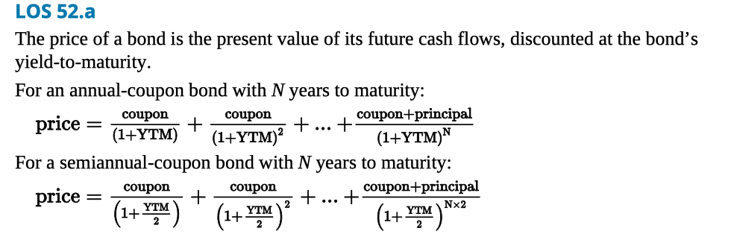

LOS 52.b A bond’s price and YTM are inversely related. An increase in YTM decreases the price and a decrease in YTM increases the price.

A bond will be priced at a discount to par value if its coupon rate is less than its YTM, and at a premium to par value if its coupon rate is greater than its YTM.

Prices are more sensitive to changes in YTM for bonds with lower coupon rates and longer maturities, and less sensitive to changes in YTM for bonds with higher coupon rates and shorter maturities.

A bond’s price moves toward par value as time passes and maturity approaches.

LOS 52.c Spot rates are market discount rates for single payments to be made in the future.

The no-arbitrage price of a bond is calculated using (no-arbitrage) spot rates as follows:

LOS 52.d The full price of a bond includes interest accrued between coupon dates. The flat price of a bond is the full price minus accrued interest.

Accrued interest for a bond transaction is calculated as the coupon payment times the portion of the coupon period from the previous payment date to the settlement date.

Methods for determining the period of accrued interest include actual days (typically used for government bonds) or 30-day months and 360-day years (typically used for corporate bonds).

LOS 52.e Matrix pricing is a method used to estimate the yield-to-maturity for bonds that are not traded or infrequently traded. The yield is estimated based on the yields of traded bonds with the same credit quality. If these traded bonds have different maturities than the bond being valued, linear interpolation is used to estimate the subject bond’s yield.

LOS 52.f

The effective yield of a bond depends on its periodicity, or annual frequency of coupon payments. For an annual-pay bond the effective yield is equal to the yield-to-maturity. For bonds with greater periodicity, the effective yield is greater than the yield-to- maturity.

A YTM quoted on a semiannual bond basis is two times the semiannual discount rate.

Bond yields that follow street convention use the stated coupon payment dates. A true yield accounts for coupon payments that are delayed by weekends or holidays and may be slightly lower than a street convention yield.

Current yield is the ratio of a bond’s annual coupon payments to its price. Simple yield adjusts current yield by using straight-line amortization of any discount or premium.

For a callable bond, a yield-to-call may be calculated using each of its call dates and prices. The lowest of these yields and YTM is a callable bond’s yield-to-worst.

Floating rate notes have a quoted margin relative to a reference rate, typically LIBOR. The quoted margin is positive for issuers with more credit risk than the banks that quote LIBOR and may be negative for issuers that have less credit risk than loans to these banks. The required margin on a floating rate note may be greater than the quoted margin if credit quality has decreased, or less than the quoted margin if credit quality has increased.

For money market instruments, yields may be quoted on a discount basis or an add-on basis, and may use 360-day or 365-day years. A bond-equivalent yield is an add-on yield based on a 365-day year.

LOS 52.g A yield curve shows the term structure of interest rates by displaying yields across different maturities.

The spot curve is a yield curve for single payments in the future, such as zero-coupon bonds or stripped Treasury bonds.

The par curve shows the coupon rates for bonds of various maturities that would result in bond prices equal to their par values.

A forward curve is a yield curve composed of forward rates, such as 1-year rates available at each year over a future period.

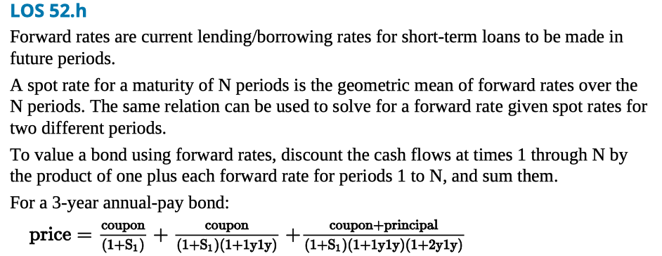

LOS 52.i A yield spread is the difference between a bond’s yield and a benchmark yield or yield curve. If the benchmark is a government bond yield, the spread is known as a government spread or G-spread. If the benchmark is a swap rate, the spread is known as an interpolated spread or I-spread.

A zero-volatility spread or Z-spread is the percent spread that must be added to each spot rate on the benchmark yield curve to make the present value of a bond equal to its price.

An option-adjusted spread or OAS is used for bonds with embedded options. For a callable bond, the OAS is equal to the Z-spread minus the call option value in basis points.

LOS 53.a The primary benefits of the securitization of financial assets are:

Reduce the funding costs for firms selling the financial assets to the securitizing entity.

Increase the liquidity of the underlying financial assets.

LOS 53.b Parties to a securitization are a seller of financial assets, a special purpose entity (SPE), and a servicer.

The seller is the firm that is raising funds through the securitization.

An SPE is an entity independent of the seller. The SPE buys financial assets from the seller and issues asset-backed securities (ABS) supported by these financial assets.

The servicer carries out collections and other responsibilities related to the financial assets. The servicer may be the same entity as the seller but does not have to be.

The SPE may issue a single class of ABS or multiple classes with different priorities of claims to cash flows from the pool of financial assets.

LOS 53.c Asset-backed securities (ABS) can be a single class of securities or multiple classes with differing claims to the cash flows from the underlying assets. Time tranching refers to classes that receive the principal payments from underlying securities sequentially as each prior tranche is repaid in full. With credit tranching, any credit losses are first absorbed by the tranche with the lowest priority, and after that by any other subordinated tranches, in order. Some structures have both time tranching and credit tranching.

LOS 53.d Characteristics of residential mortgage loans include:

Maturity.

Interest rate: fixed-rate, adjustable-rate, or convertible.

Amortization: full, partial, or interest-only.

Prepayment penalties.

Foreclosure provisions: recourse or nonrecourse.

The loan-to-value (LTV) ratio indicates the percentage of the value of the real estate collateral that is loaned. Lower LTVs indicate less credit risk.

LOS 53.e Agency residential mortgage-backed securities (RMBS) are guaranteed and issued by GNMA, Fannie Mae, or Freddie Mac. Mortgages that back agency RMBS must be conforming loans that meet certain minimum credit quality standards. Nonagency RMBS are issued by private companies and may be backed by nonconforming mortgages.

Key characteristics of RMBS include:

Pass-through rate, the coupon rate on the RMBS.

Weighted average maturity (WAM) and weighted average coupon (WAC) of the underlying pool of mortgages.

Conditional prepayment rate (CPR), which may be compared to the Public Securities Administration (PSA) benchmark for expected prepayment rates.

Nonagency RMBS typically include credit enhancement. External credit enhancement is a third-party guarantee. Internal credit enhancement includes reserve funds (cash or excess spread), overcollateralization, and senior/subordinated structures.

Collateralized mortgage obligations (CMOs) are collateralized by pools of residential MBS. CMOs are structured with tranches that have different exposures to prepayment risks.

In a sequential-pay CMO, all scheduled principal payments and prepayments are paid to each tranche in sequence until that tranche is paid off. The first tranche to be paid principal has the most contraction risk and the last tranche to be paid principal has the most extension risk.

A planned amortization class (PAC) CMO has PAC tranches that receive predictable cash flows as long as the prepayment rate remains within a predetermined range, and support tranches that have more contraction risk and more extension risk than the PAC tranches.

LOS 53.f Prepayment risk refers to uncertainty about the timing of the principal cash flows from an ABS. Contraction risk is the risk that loan principal will be repaid more rapidly than expected, typically when interest rates have decreased. Extension risk is the risk that loan principal will be repaid more slowly than expected, typically when interest rates have increased.

LOS 53.g Commercial mortgage-backed securities (CMBS) are backed by mortgages on income- producing real estate properties. Because commercial mortgages are nonrecourse loans, analysis of CMBS focuses on credit risk of the properties. CMBS are structured in tranches with credit losses absorbed by the lowest priority tranches in sequence.

Call (prepayment) protection in CMBS includes loan-level call protection such as prepayment lockout periods, defeasance, prepayment penalty points, and yield maintenance charges, and CMBS-level call protection provided by the lower-priority tranches.

LOS 53.h Asset-backed securities may be backed by financial assets other than mortgages. Two examples are auto loan ABS and credit card ABS.

Auto loan ABS are backed by automobile loans, which are typically fully amortizing but with shorter maturities than residential mortgages. Prepayments result when autos are sold or traded in, stolen or wrecked and paid off from insurance proceeds, refinanced, or paid off from the borrower’s excess cash.

Credit card ABS are backed by credit card receivables, which are revolving debt (nonamortizing). Credit card ABS typically have a lockout period during which only interest is paid to investors and principal payments on the receivables are used to purchase additional receivables.

LOS 53.i Collateralized debt obligations (CDOs) are structured securities backed by a pool of debt obligations that is managed by a collateral manager. CDOs include:

Collateralized bond obligations (CBOs) backed by corporate and emerging market debt.

Collateralized loan obligations (CLOs) backed by leveraged bank loans.

Structured finance CDOs backed by residential or commercial MBS, ABS, or other CLOs.

Synthetic CDOs backed by credit default swaps on structured securities.

Reading 54 Understanding Fixed Income Risk and Return

LOS 54.a Sources of return from a bond investment include:

Coupon and principal payments.

Reinvestment of coupon payments.

Capital gain or loss if bond is sold before maturity.

Changes in yield to maturity produce market price risk (uncertainty about a bond’s price) and reinvestment risk (uncertainty about income from reinvesting coupon payments). An increase (a decrease) in YTM decreases (increases) a bond’s price but increases (decreases) its reinvestment income.

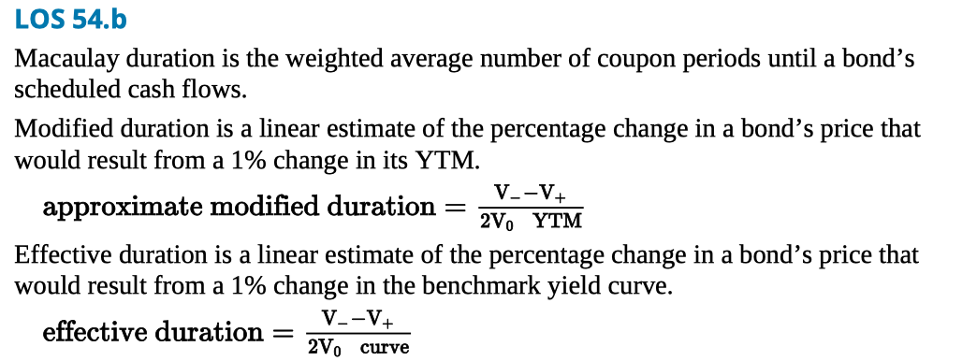

LOS 54.c Effective duration is the appropriate measure of interest rate risk for bonds with embedded options because changes in interest rates may change their future cash flows. Pricing models are used to determine the prices that would result from a given size change in the benchmark yield curve.

LOS 54.d Key rate duration is a measure of the price sensitivity of a bond or a bond portfolio to a change in the spot rate for a specific maturity. We can use the key rate durations of a bond or portfolio to estimate its price sensitivity to changes in the shape of the yield curve.

LOS 54.e Holding other factors constant:

Duration increases when maturity increases.

Duration decreases when the coupon rate increases.

Duration decreases when YTM increases.

LOS 54.f There are two methods for calculating portfolio duration:

Calculate the weighted average number of periods until cash flows will be received using the portfolio’s IRR (its cash flow yield). This method is better theoretically but cannot be used for bonds with options.

Calculate the weighted average of durations of bonds in the portfolio (the method most often used). Portfolio duration is the percentage change in portfolio value for a 1% change in yield, only for parallel shifts of the yield curve.

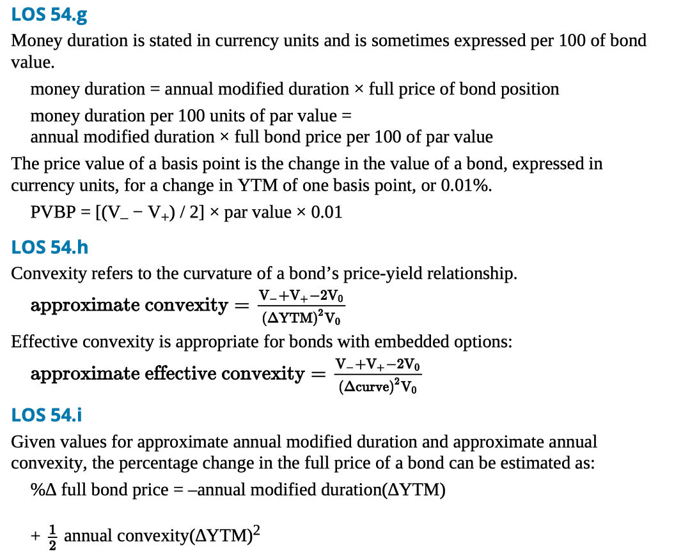

LOS 54.j The term structure of yield volatility refers to the relationship between maturity and yield volatility. Short-term yields may be more volatile than long-term yields. As a result, a short-term bond may have more price volatility than a longer-term bond with a higher duration.

LOS 54.k Over a short investment horizon, a change in YTM affects market price more than it affects reinvestment income.

Over a long investment horizon, a change in YTM affects reinvestment income more than it affects market price.

Macaulay duration may be interpreted as the investment horizon for which a bond’s market price risk and reinvestment risk just offset each other.

duration gap = Macaulay duration − investment horizon

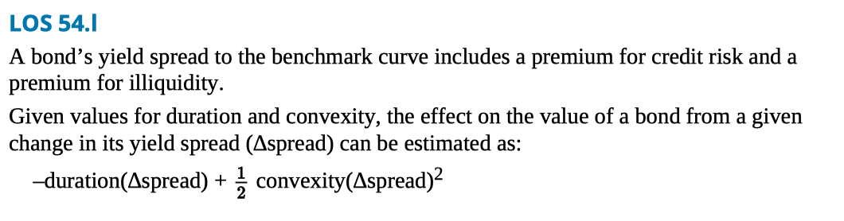

Reading 55 Fundamental of Credit Analysis

LOS 55.a Credit risk refers to the possibility that a borrower fails to make the scheduled interest payments or return of principal. Spread risk is the possibility that a bond loses value because its credit spread widens relative to its benchmark. Spread risk includes credit migration or downgrade risk and market liquidity risk.

LOS 55.b Credit risk is composed of default risk, which is the probability of default, and loss severity, which is the portion of the value of a bond or loan a lender or investor will lose if the borrower defaults. The expected loss is the probability of default multiplied by the loss severity.

LOS 55.c Corporate debt is ranked by seniority or priority of claims. Secured debt is a direct claim on specific firm assets and has priority over unsecured debt. Secured or unsecured debt may be further ranked as senior or subordinated. Priority of claims may be summarized as follows: First mortgage or first lien. Second or subsequent lien. Senior secured debt. Senior unsecured debt. Senior subordinated debt. Subordinated debt. Junior subordinated debt.

LOS 55.d Issuer credit ratings, or corporate family ratings, reflect a debt issuer’s overall creditworthiness and typically apply to a firm’s senior unsecured debt. Issue credit ratings, or corporate credit ratings, reflect the credit risk of a specific debt issue. Notching refers to the practice of adjusting an issue credit rating upward or downward from the issuer credit rating to reflect the seniority and other provisions of a debt issue.

LOS 55.e Lenders and bond investors should not rely exclusively on credit ratings from rating agencies for the following reasons: Credit ratings can change during the life of a debt issue. Rating agencies cannot always judge credit risk accurately. Firms are subject to risk of unforeseen events that credit ratings do not reflect.

Market prices of bonds often adjust more rapidly than credit ratings.

LOS 55.f Components of traditional credit analysis are known as the four Cs:

Capacity: The borrower’s ability to make timely payments on its debt.

Collateral: The value of assets pledged against a debt issue or available to creditors if the issuer defaults.

Covenants: Provisions of a bond issue that protect creditors by requiring or prohibiting actions by an issuer’s management.

Character: Assessment of an issuer’s management, strategy, quality of earnings, and past treatment of bondholders.

LOS 55.g Credit analysts use profitability, cash flow, and leverage and coverage ratios to assess debt issuers’ capacity.

Profitability refers to operating income and operating profit margin, with operating income typically defined as earnings before interest and taxes (EBIT).

Cash flow may be measured as earnings before interest, taxes, depreciation, and amortization (EBITDA); funds from operations (FFO); free cash flow before dividends; or free cash flow after dividends.

Leverage ratios include debt-to-capital, debt-to-EBITDA, and FFO-to-debt.

Coverage ratios include EBIT-to-interest expense and EBITDA-to-interest expense.

LOS 55.h Lower leverage, higher interest coverage, and greater free cash flow imply lower credit risk and a higher credit rating for a firm. When calculating leverage ratios, analysts should include in a firm’s total debt its obligations such as underfunded pensions and off-balance-sheet financing.

For a specific debt issue, secured collateral implies lower credit risk compared to unsecured debt, and higher seniority implies lower credit risk compared to lower seniority.

LOS 55.i Corporate bond yields comprise the real risk-free rate, expected inflation rate, credit spread, maturity premium, and liquidity premium. An issue’s yield spread to its benchmark includes its credit spread and liquidity premium.

The level and volatility of yield spreads are affected by the credit and business cycles, the performance of financial markets as a whole, availability of capital from broker- dealers, and supply and demand for debt issues. Yield spreads tend to narrow when the credit cycle is improving, the economy is expanding, and financial markets and investor demand for new debt issues are strong. Yield spreads tend to widen when the credit cycle, the economy, and financial markets are weakening, and in periods when the supply of new debt issues is heavy or broker-dealer capital is insufficient for market making.

LOS 55.j High yield bonds are more likely to default than investment grade bonds, which increases the importance of estimating loss severity. Analysis of high yield debt should focus on liquidity, projected financial performance, the issuer’s corporate and debt structures, and debt covenants.

Credit risk of sovereign debt includes the issuing country’s ability and willingness to pay. Ability to pay is greater for debt issued in the country’s own currency than for debt issued in a foreign currency. Willingness refers to the possibility that a country refuses to repay its debts.

Analysis of non-sovereign government debt is similar to analysis of sovereign debt, focusing on the strength of the local economy and its effect on tax revenues. Analysis of municipal revenue bonds is similar to analysis of corporate debt, focusing on the ability of a project to generate sufficient revenue to service the bonds.